



Office of Assessment &
Academic Program Review
UNM State of GE Report

GE Assessment Results

2019-2025
October 2025

UNM State of GE Report

This report provides a summary of current and historical skill assessment from certified courses in the general education (GE) program at The University of New Mexico (UNM). This compilation marks the conclusion of two three-year GE assessment cycles since the New Mexico Higher Education Department (NMHED) revised GE standards in 2018.

Six years of UNM General Education: Overview
NMHED defined five essential skills for all NM postsecondary programs to assess in their certified GE courses: Communication, Critical Thinking, Information & Digital Literacy, Personal & Social Responsibility, and Quantitative Reasoning. The seven UNM GE content areas were aligned by NMHED to map to three essential skills each as shown in the following Figure 1: I. Communication; II. Mathematics: Mathematics and Statistics; III. Science: Physical and Natural Sciences; IV. Social and Behavioral Sciences; V-A. Humanities and V-B. Second Language; VI. Creative and Fine Arts: Arts and Design.

Figure 1 NMHED Essential Skills (3) identified for each UNM General Education Content Areas (7)

GE measurement and analysis: Since 2019, the University of New Mexico Office of Assessment and Academic Program Review (OAAPR) has overseen GE assessment. The first three-year cycle of assessment occurred in 2019-2021 and the second cycle occurred in 2022-2025.
- UNM Assessment Cycle: The assessment cycle operates on a 3-year basis. Three of five total essential skills are assigned to each of six GE content areas. In a three-year cycle, one essential skill (spanning several GE areas) is assessed per year. Instructors assess their courses on a rotating basis throughout each cycle.
- Sampling: Designated instructors within each college/school/branch collect and submit student artifacts. A specified number of sections of GE courses are selected for assessment per UNM content areas (I-VI): typically, 5-10 sections unless otherwise arranged with OAAPR).
- Artifact Collection: Instructors submit student completed artifacts using the GE Assessment Artifact Submission Form. Artifacts are submitted by December 15 for Fall sections and May 15 for Spring sections annually. A minimum of four student artifacts are submitted per course section, along with a completed fillable form providing information about the section and assignment to which the artifacts respond.

- Rating Process and Reporting: OAAPR oversees the analysis of GE student artifacts by UNM graduate student raters with experience teaching UNM GE courses. OAAPR trains raters to analyze the artifacts using essential skill rubrics developed by the NMHED. Raters follow a 0-3 rubric scale to evaluate skill development as evidenced in an artifact:
0: No evidence
1: Emerging
2: Developing
3: Proficient.
Qualitative notes and quantitative ratings are aggregated and reported to the OAAPR. OAAPR provides an annual institutional report and individualized GE reports for each participating college, school, and branch.
- NMHED rubric Dimensions: Each of the five essential skills is comprised of several dimensions. Raters measure dimensions in determining evidence of essential skill development.
Variables beyond student performance: Student demographics, status, course level in GE (1000 and 2000), essential skill requirement per content area, rubric dimension selection, and assignment/artifact alignment (the degree to which the assignment prompt and/or artifact matches the descriptions outlined in the rubric definition and dimensions.)

Integration with UNM 2040 Strategic Goals

UNM GE assessment activities and efforts fit with the mission to educate and serve diverse people of New Mexico and the world through comprehensive programs of GE teaching, research, and public service. The teaching and assessing of GE essential skills support UNM 2040 strategic goals, including:

Improving Personal and Social Responsibility (Goal 1: Advance New Mexico, Goal 2: Community Engagement & Impact, and Goal 4: Sustainability)

Enhancing Information Digital Literacy (Goal 1: Advance New Mexico, Goal 2: Student Success, and Goal 3: Academic Excellence)

Developing Quantitative Reasoning (Goal 1: Advance New Mexico, Goal 3: Academic Excellence, and Goal 5: One University)

Building Critical Thinking (Goal 1: Advance New Mexico, Goal 2: Student Success, Goal 3: Academic Excellence, and Goal 5: One University)

Cultivating effective Communication skills (Goal 1: Advance New Mexico, Goal 2: Community Engagement & Impact, and Goal 3: Academic Excellence).

Message for Instructors: Assess for the Improvement of Student Success
General Education instructors help students become ready for career, community, and the world when they address:
- Introduction, Reinforcement and Assessment of Student Skill Attainment: Include multiple feedback mechanisms to facilitate self-assessment and metacognition, enabling students to identify areas of strength and improvement and track learning progress. Develop tailored learning that integrate transferable skills, preparing students for future education and industry demands.
- Curriculum Development: Align course design, activities, and rubrics with student learning outcomes for each course to ensure cohesive learning experiences. (See the NMHED catalog of course SLOs; note that UNM courses may include some additional SLOs identified departmentally). Use results to inform curriculum development and identify areas for improvement. Create flexible pathways that cater to individual student needs, fostering a more inclusive and effective learning environment.
- GE Content Area Success: Explore GE skill assessment data to identify areas that need improvement. Use assessment insights to inform teaching strategies and enhance content delivery. Develop content that integrates real-world applications, promoting deeper learning and increased student engagement.
- Student Experience and well-being: Introduce and reinforce GE essential skills, building a foundation for increased learner sophistication and confidence. Offer personalized learning plans, goal setting, and progress tracking to support student growth and self-awareness. Foster a growth mindset, encouraging students to persist through challenges and develop resilience.

Top GE Takeaways

Engagement: GE assessment findings of six years highlight a significant increase in participation from Cycle 1 (Pilot) to Cycle 2, demonstrating the growing maturity of and engagement in assessment processes over time. This upward trend in GE assessment submission and data-driven insights positions us well to continue refining our GE program and enhancing student success in Cycle 3, beginning in Fall 2025. An unexpected pattern in artifact collection has emerged from six years of General Education (GE) assessment. Most assignments from GE assessment sampling represented sophomores and juniors, followed by seniors and a smaller proportion of freshmen. In Fall 2025, the UNM Institute for Design Innovation analyzed how students distribute their general education enrollment by college year, defining the cohort as First-Time, Full-Time students who entered UNM between Fall 2017 and Fall 2022 who received the Bachelor's Degree:

25% of FTFT students who graduate complete GE in 3 semesters

50% of FTFT students who graduate complete GE in 4 semesters

75% of FTFT students who graduate complete GE in 6 semesters

Students take GE courses throughout their undergraduate years.
- 1000- and 2000- level GE courses: Critical Thinking and Communication skills improve from the 1000-level to the 2000-level. Quantitative Reasoning is measured most strongly in Area II, with Developing (2) ratings in the 1000- and 2000- levels. Personal and Social Responsibility and Information Digital Literacy skills scored just above the emerging (1) rating at both the 1000- and 2000- levels.
- UNM Content Areas: Performance varies across content areas, with Areas II and IV showing strong performance and Areas III and V exhibiting more variability. This suggests areas for potential improvement and refinement in content areas.
- Dimensions of Essential Skills: Students need more help learning to Evaluate and Produce Arguments (Critical Thinking), develop Digital Literacy, and improve their Understanding of Information Structures (Information and Digital Literacy). Additionally, Evidence Evaluation (Critical Thinking) needs bolstering. All dimensions of Personal and Social Responsibility need attention.
- Alignment: Ratings are lower, not surprisingly, for student artifacts linked to instructor assignments that did not solicit demonstration of an essential skill. Over time, instructor alignment of assignments with essential skills has improved. Misalignment highlights the importance of tying curriculum to assessment.
Results

GE Participation
A total of 4,695 artifacts were submitted for GE assessment by GE instructors from 2019 to 2025, representing seven colleges and schools (out of eight) and all four branches. The following graph provides distribution of artifact submission for each 3-year cycle.
Graph 1. Overall artifact submission participation from AY 2019 to 2025
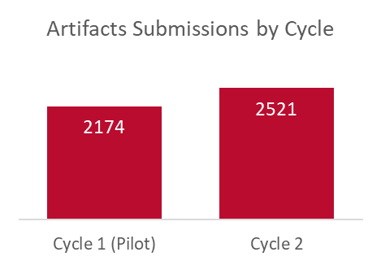

Student Demographics
The artifact submissions reflect a diverse UNM GE student population from 2019 to 2025. Key demographics include:
- Gender: 62% female, 37% male, and 1% non-reported.
- Race & Ethnicity: 46.3% Hispanic/Latino, 31.4% White, 8.5% American Indian, 5.1% Asian, 1.8% Black/African American, 3.2% Two or More, 2.1% International (no race/ethnicity reported), 1.8% Race-ethnicity unknown.
- Student Classification: 7.9% concurrent enrollment and 11.5% freshmen; 40.4% sophomores; 21.1% juniors; 16.0% seniors; 2.1% non-degree, .8% graduate, and 1.4% other.

Essential Skill Ratings
Graph 2. Overall Distribution of Average Ratings (1000 and 2000), 2019-2025
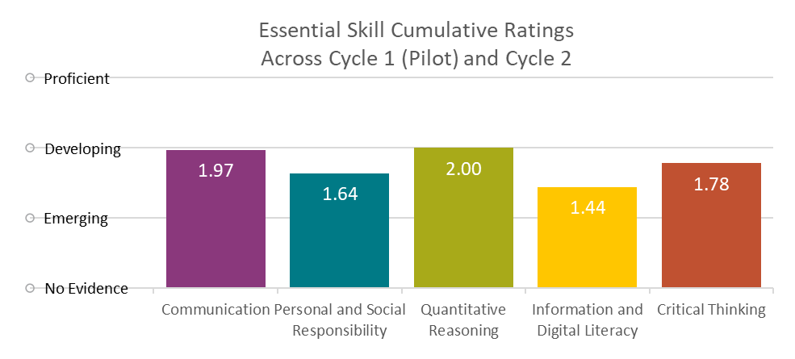

Graph 2 indicates varying levels of proficiency across the five NMHED essential skills. Quantitative Reasoning (QR), Communication (Comm), and Critical Thinking (CT) demonstrate the highest ratings, with average scores at or nearing the Developing benchmark (rating of 2 on a scale of 0-3, with 1 being Emerging, 2 Developing and 3 Proficient). This suggests that students are showing promising growth in these areas, primarily within QR and Communication skills. In contrast, Personal and Social Responsibility (PSR) and Information & Digital Literacy (IDL) skills scored lower, with average ratings at the Emerging benchmark (rating of 1). Overall, PSR shows potential for growth, approaching the Developing benchmark. IDL, however, indicates a greater need for improvement. Analysis identified challenges in aligning certain artifacts in IDL and PSR with the assessment rubrics in both self-selected dimensions, which may have impacted the scores. A more detailed analysis at the course level (presented in the next table) provides a clearer picture of student performance and highlights specific areas for targeted support.

Graph 3. Overall Distribution of Average Ratings by Essential Skill and Course Level (1000 and 2000), 2019-2025
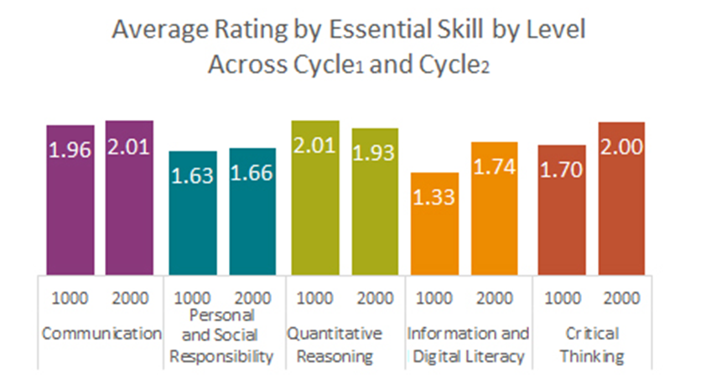

- Communication (COM): Both 1000- and 2000-level courses demonstrate similar ratings around the Developing benchmark (rating of 2 out of 3). This suggests consistent and similar performance across course levels.
- Quantitative Reasoning (QR): Similar to COMM, QR shows comparable ratings at the Developing benchmark between 1000 and 2000 courses, with 2000 courses scoring slightly lower, which can be due to low submissions, and random selection of assignments.
- Critical Thinking (CT): 2000-level courses exhibit higher ratings than 1000-level courses, with 2000-level courses reaching the Developing benchmark and 1000-level approaching it (rating 1 indicating Emerging benchmark). This indicates that students are developing their critical thinking skills as they progress through their coursework.
- Information Digital Literacy (IDL): Although 2000-level courses show higher ratings than 1000-level courses, the overall scores remain low, particularly in the 1000-level. This suggests a need for improvement in IDL across both course levels.
- Personal and Social Responsibility (PSR): PSR ratings remain quasi-identical between 1000 and 2000 courses, with both levels scoring at the Emerging benchmark. This lack of growth needs attention, given PSR's importance to UNM's mission and 2040 strategic goals.
Shifting the focus from overall skill performance to a distribution by content area displayed in Graph 4 below provides a more nuanced understanding of student learning outcomes. This breakdown is important because it allows us to identify specific areas of strength and weakness within each GE content area at UNM, enabling targeted support and improvement initiatives that can enhance student learning and achievement.

Graph 4. Overall Distribution of Average Ratings by Essential Skill, Course Level (1000 and 2000) and GE content area, 2019-2025
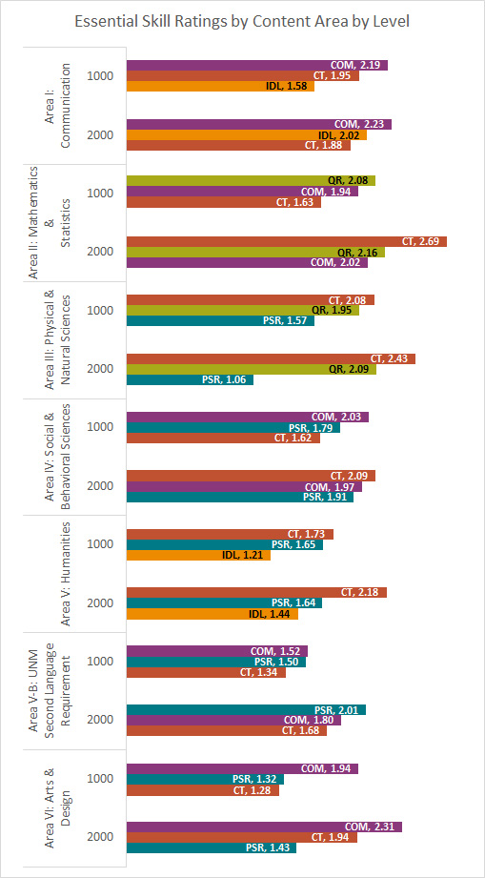

In 2019, each UNM content area was mapped with three essential skills by the NMHED. The following results emerged over time:
- Content Area I demonstrate a solid Emerging benchmark rating in COMM, with a slight increase in 2000 courses. CT ratings remain consistent across both course levels, while Information Digital Literacy shows improvement from Emerging to Solid Emerging in 2000 courses.
- Content Area II indicates stronger performance, with QR and COMM both achieving a Developing benchmark rating in 1000 and 2000 level courses. CT shows a substantial increase from Emerging to Developing in 2000 courses.
- Content Area III CT excels with a solid Developing benchmark ratings in both course levels, with an increase in 2000 level courses. QR maintains similar ratings near the Developing benchmark in both course levels. However, PSR falls behind, with an Emerging benchmark rating and a decrease in 2000 level courses.
- Content Area IV demonstrates solid performance in COMM and CT, with the latter reaching solid Developing benchmark ratings in 2000 level courses. PSR approaches the Developing benchmark in 1000 and 2000 course levels.
- Content Area V-A shows promising growth in CT, with ratings increasing from approaching Developing to solid Developing achievement in 2000 level courses. However, PSR remains at the Emerging benchmark, and Information & Digital Literacy findings show the lowest ratings in this content area.
- Content Area V-B indicates varied results, with COMM and CT both starting at an Emerging benchmark rating and showing slight increases in 2000 level courses. In this area, PSR jumps to the Developing benchmark in 2000 courses.
- Content Area VI demonstrates a solid Emerging benchmark rating in COMM, with a slight increase in 2000 courses. CT substantially increases in 2000 levels almost at the Emerging benchmark. PSR remains at the Emerging benchmark, with the lowest ratings in this area.

Alignment
Graph 5. Overall Average percentage for Alignment from 2019 to 2025
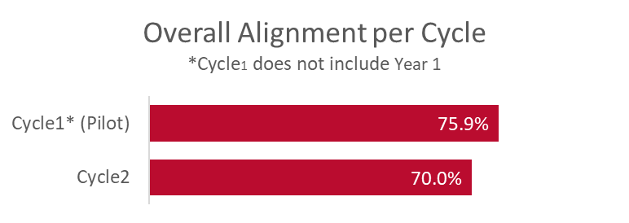
The connections between assignments, instructor NMHED essential skill rubric dimension selection, and NMHED essential skill rubric definitions is a large factor in GE skill ratings. Over time, the OAAPR began collecting data and analyzing how alignment is a factor in UNM essential skill results. When alignment does not exist or is poor, meaning essential skill rubric language is not connected to assignment (prompts) and the assessment process, ratings deflate. When alignment does exist or is strong, meaning essential skill rubric language is consistently reflected in assignments, ratings inflate. Over the last two cycles, the alignment is averaging at 72.7%. However, alignment has decreased in the most current assessment cycle, which explains a decrease in essential skill ratings. Concerted efforts to align the NMHED definitions and GE course assignments is important for strengthening UNM’s understanding of student performance. The higher the alignment, the more ratings are reliably based on student essential skill attainment.

Dimension Ratings
Graphs 6 and 7. Overall Rubric Dimension average ratings for Communication and Quantitative Reasoning from 2019 to 2025
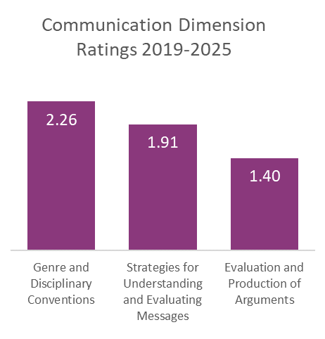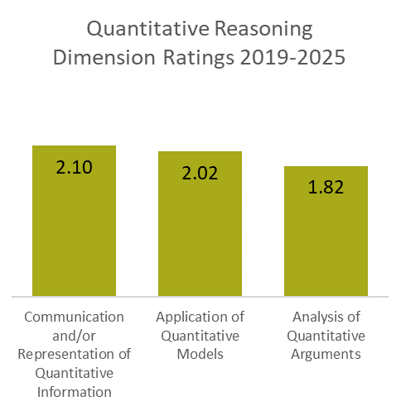
While communication and QR are UNM’s strongest ranked essential skills, specific dimensions are adversely affecting ratings. In Communication, students demonstrate strength in the Genre and Disciplinary Conventions dimension, achieving a solid average in the Developing benchmark. However, the Strategies dimension falls slightly short, while the more advanced dimension of Evaluation and Production of Arguments shows a greater need for improvement, with ratings nearing the Emerging benchmark.
Quantitative Reasoning highlights consistency in Communication and Application of Quantitative Models, with solid average ratings at the Developing benchmark. Meanwhile, the more advanced Analysis of Arguments dimension is nearing the Developing benchmark, indicating some opportunity for growth.
Graphs 8 and 9. Overall Rubric Dimension average ratings for Information & Digital Literacy and Personal & Social Responsibility from 2019 to 2025
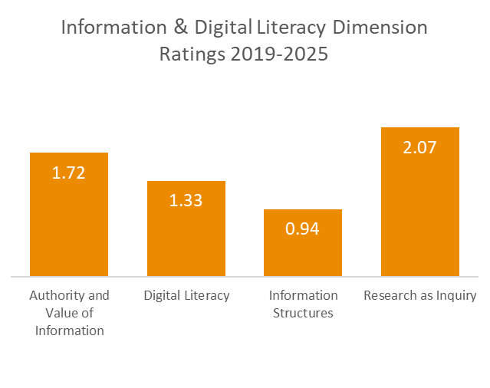
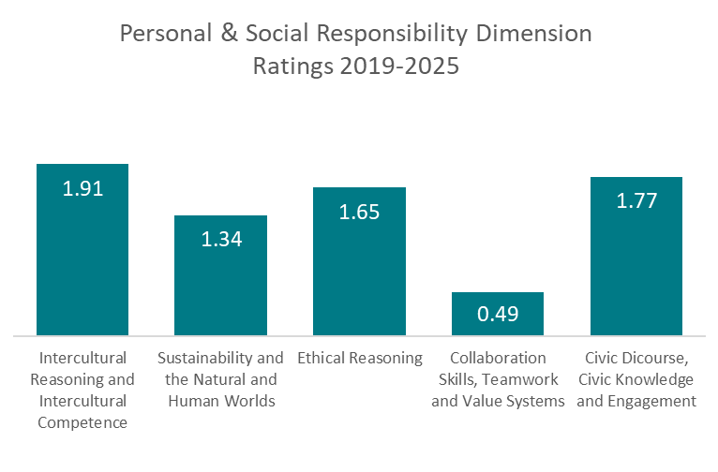
The assessment results for the Information & Digital Literacy and Personal and Social Responsibility skills reveal areas of strength and concern. In IDL, students demonstrate relative strength in the Research as Inquiry dimension, achieving a solid average in the Developing benchmark. The Authority and Value dimension shows promise, approaching the Developing benchmark, but Digital Literacy lags behind, scoring only a mid-Emerging benchmark. The Information Structures dimension is the lowest scoring, measuring below the Emerging benchmark.

None of the PSR dimensions meet the Developing benchmark. Specifically, Sustainability and Collaboration Teamwork show the lowest results, with the latter dimension not even approaching the Emerging benchmark. These findings underscore the need for targeted interventions to improve student performance in both the PSR and IDL essential skills. The OAAPR recommends incorporating and practicing these dimensions in course activities, assignments and reflecting the language in related assignment prompts.
Graph 10. Overall Rubric Dimension average ratings for Critical Thinking from 2019 to 2025

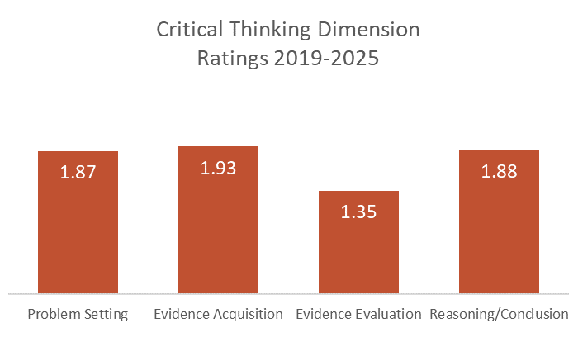
For Critical Thinking, the only essential skill that is common to all UNM General Education content areas, assessment results demonstrate consistently positive performance, with most dimensions approaching the Developing benchmark. However, the Evidence Evaluation dimension requires attention, scoring substantially lower with an average rating below mid-Emerging benchmark.

Themes and Patterns identified by Raters
The review of submitted assignment prompts revealed a range of strengths as well as opportunities for growth. Some assignments demonstrated effective integration of skills into their assessments. However, other assignment prompts were deemed too narrow, limited, or vague, resulting in misalignment with the intended essential skill and its dimensions. Raters, considering their familiarity with the content area, positively filled in gaps where instructor intentions or assessment criteria may have been unclear. A consensus emerged among raters regarding the need for more explicit prompts with clearer alignment to specific dimensions. As one rater astutely noted, "Ensuring alignment between course objectives and assessment criteria is crucial for accurate measurement of student learning." This quote highlights the importance of refining assessment processes to ensure validity and reliability. The consistently low ratings in Personal and Social Responsibility over six years call for targeted support to help students develop this essential skill. In response to rater recommendations and quantitative data results presented above, the OAAPR is committed to providing additional guidance to instructors on assessment criteria and rubric interpretation, ensuring more effective student evaluation and reinforced instruction of the NMHED GE skills.

Next Steps
The six-year results of two cycles have sparked new OAAPR trainings and professional development support for our UNM instructors and GE coordinators. In AY 25-26, a GE annual results workshop, two assignment alignment workshops, two GE NMHED workshops ("getting to know the skills") and two designated essential skill days are being offered. These workshops focus on polishing current assignment prompts in relationship to GE student learning outcomes, NMHED essential skills, and rubric dimensions per content area in multiple UNM GE 1000 and 2000 courses.
The OAAPR will begin collaborating with Elevate GE initiatives to assist in the alignment and assessment of GE course objectives in their Canvas modules. This collaboration will also strive to include student voice in assessment of the GE experience at UNM. Additionally, the OAAPR will expand analysis to incorporate potential contributing factors to the NMHED essential skills ratings such as Student Experience Project interventions in GE courses and high-fail rate GE courses. A list of these SEP courses will be mapped with GE courses for which artifacts have been submitted. The goals are to understand the impact and ways in which instructors integrate NMHED skills, to improve professional development workshops, and to guide UNM GE instructors.
Not all UNM instructors are familiar with the NMHED GE essential skills or requirements. Early exposure to GE assessment can help. Another way is to communicate the value of essential skills to GTA and contingent faculty through professional development and departmental oversight. OAPPR will disseminate reports more broadly; GE instructors will receive consistent communications in the future, and Chairs/Program Directors will learn about GE essential skills performance in the GE courses offered by their units through Academic Program Review (APR). The addition of more professional development workshops will also be a place to bridge this awareness gap. For more information on UNM's general education assessment, please go to the UNM GE assessment website. For specific requests and support to help guide your assessment, please reach out to assess@unm.edu.

