How to upload Assessment Documents:
- Enter the Repository through this link: http://digitalrepository.unm.edu/cgi/ir_submit.cgi?context=provost_assessment
  - You will be prompted to Login using your UNM NetID
  - Do not enter your information in the Non-UNM user area below the red button.
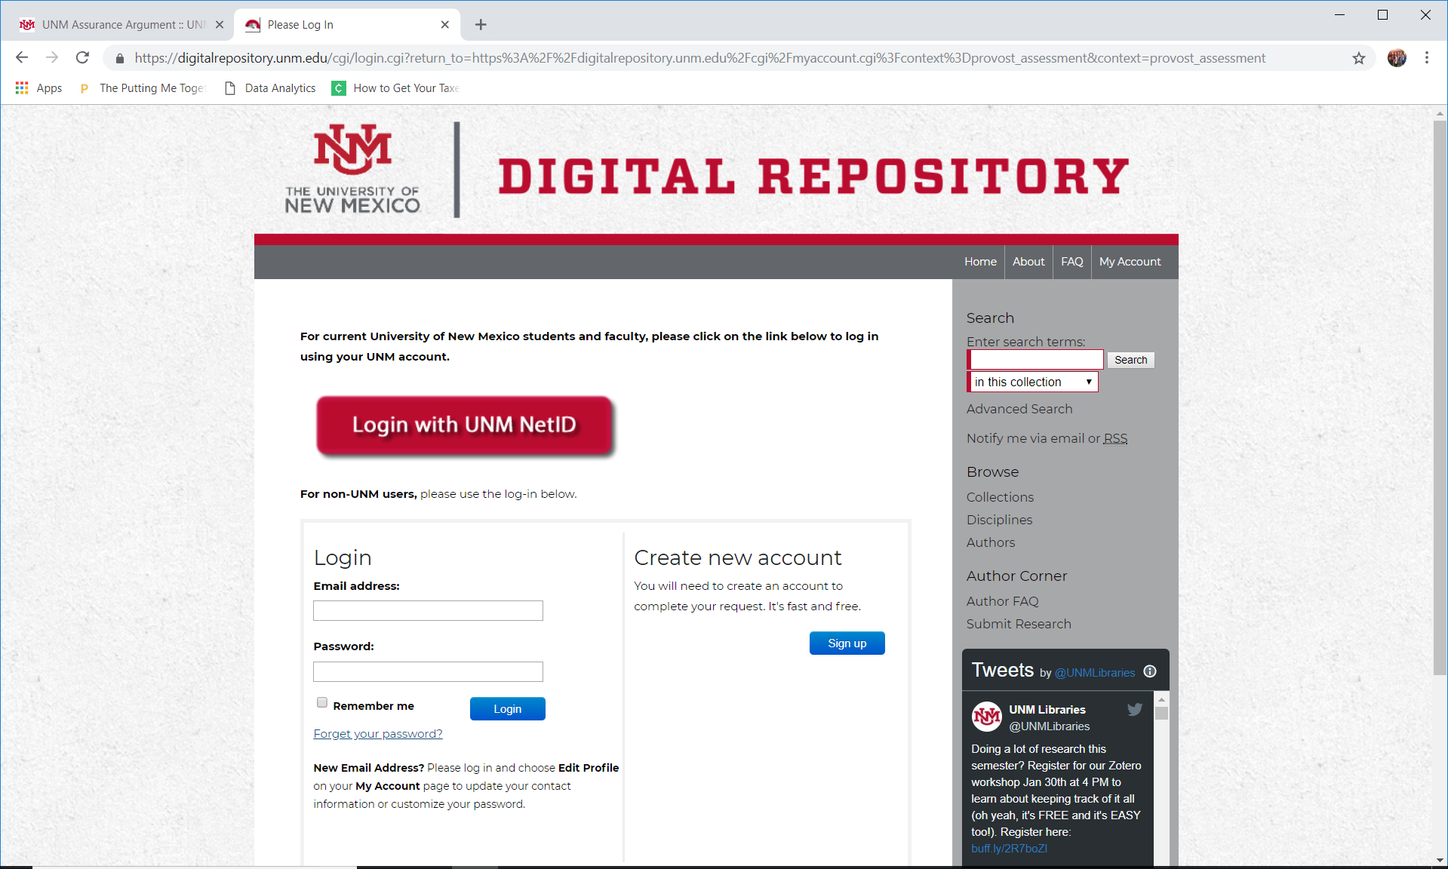
Click Here!
- You will be prompted to enter your UNM NetID and password, then select login. The screen will look like this:
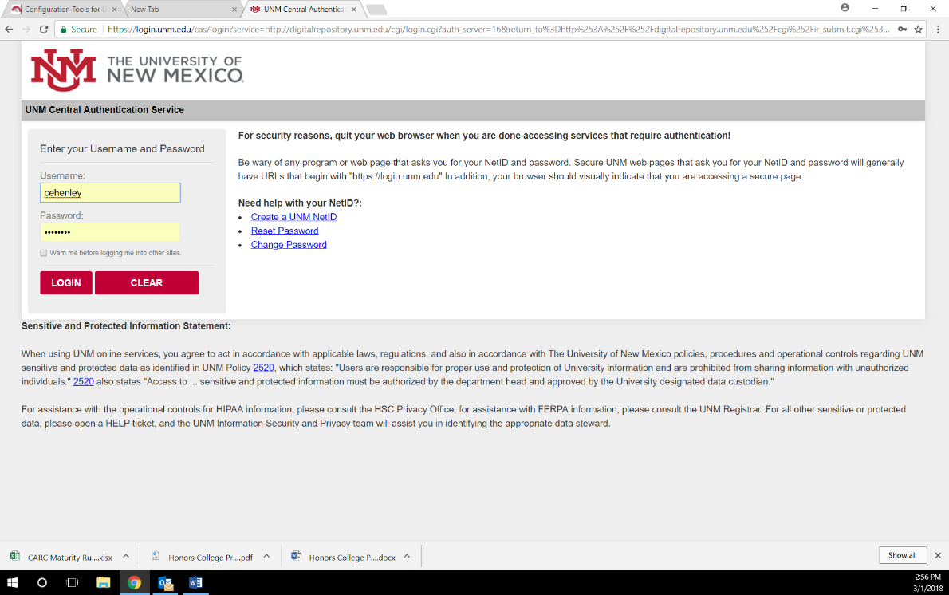

- Once logged in, you will be redirected to the submission form. If you are NOT redirected to the submission form, please click this link again: http://digitalrepository.unm.edu/cgi/ir_submit.cgi?context=provost_assessment
  - Now you should see a page that looks like this:
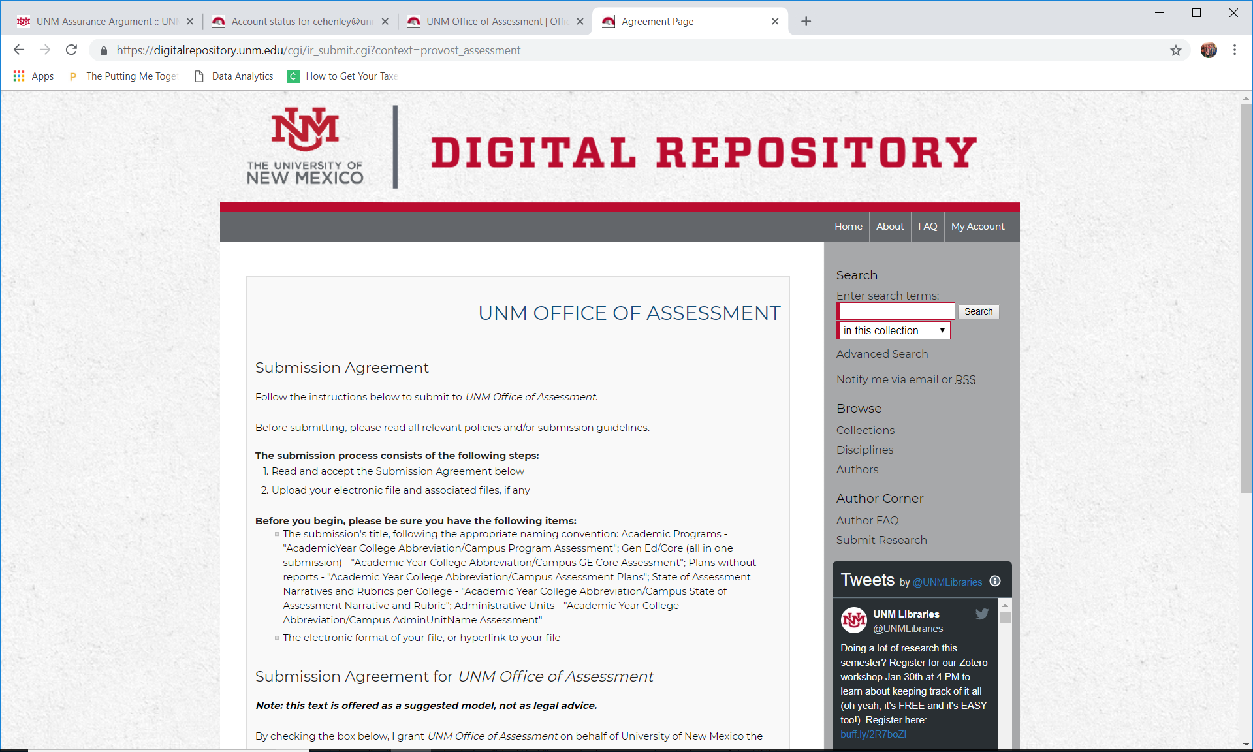

  - At the bottom on the page, check the box to agree to the terms and then select continue:
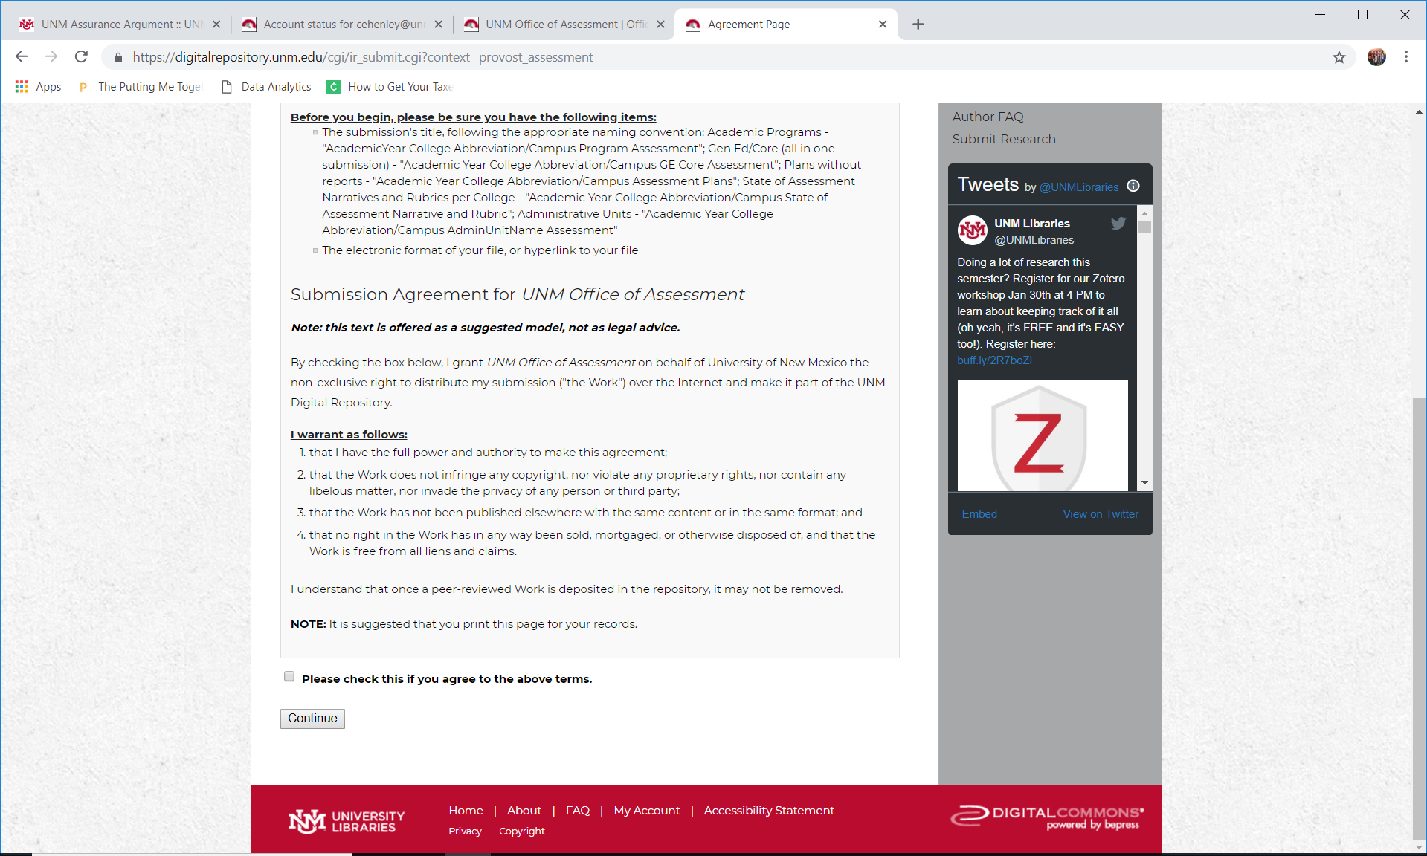
Click Here!
And Here!

- The next page will look like this:
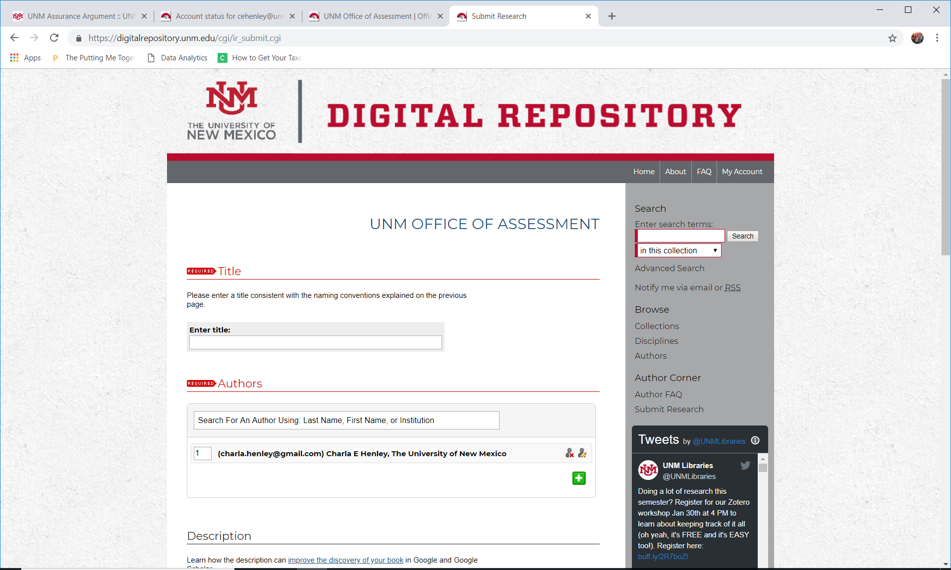
- Begin to fill-in the information for the submission
  - For Academic/Degree Programs: “Title” should follow the format [AcademicYear] [College Abbreviation/Campus] [Program] [Degree] [Assessment]
    - Ex. For the 2015/2016 Assessment documents from the Computer Engineering BS program, the title will look like:
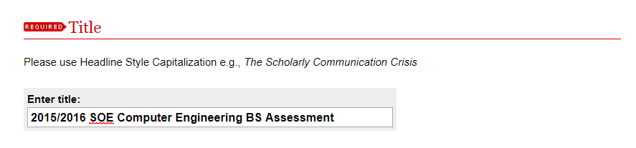
  - For other submissions, please follow these naming conventions:
    - Academic/Degree Plans without reports: [AcademicYear] [College Abbreviation/Campus] [Program] [Degree] [Assessment Plan]
    - State of Assessment Narratives and Rubrics per College: [AcademicYear] [College Abbreviation/Campus] [State of Assessment Narrative and Rubric]
    - Non-Academic/Co-Curricular Units: [AcademicYear] AC [Program or Office Name] Assessment
    - NOTE: As of Fall 2020, General Education assessment documents should not be submitted to the repository. For more information and access to the submission portal for GE documents, please see http://assessment.unm.edu/assessment-types/gened-assessment/deadlines.html.

  - In “Authors,” you will select the “person with a pencil” icon 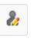
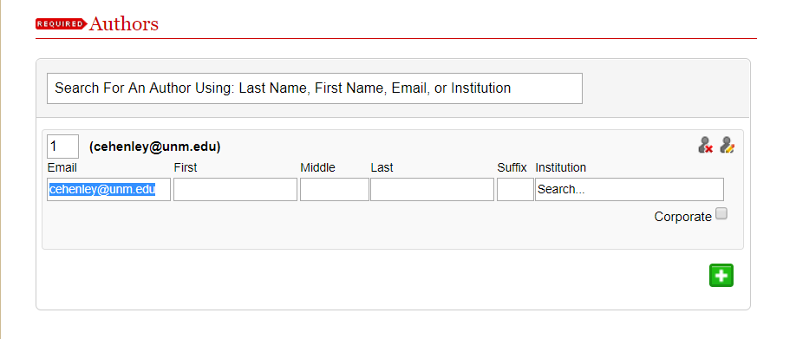
    - Next, check the box in the lower right corner that says “corporate”
Click Here!
And Here!

    - All boxes will be shaded black with the exception of the “Institution” box. In that box, type the abbreviation for your college and then the program name:
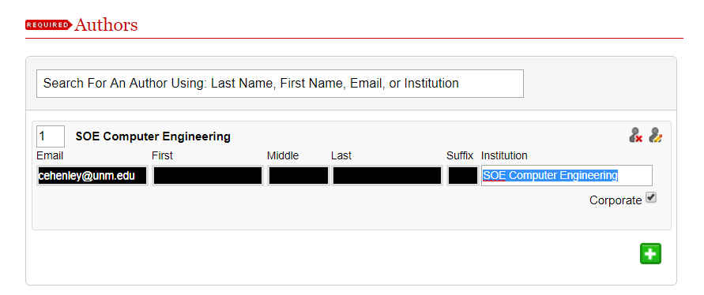
  - Skip the “Description” box, unless you have some key words or ideas you would like to have associated with your submission.
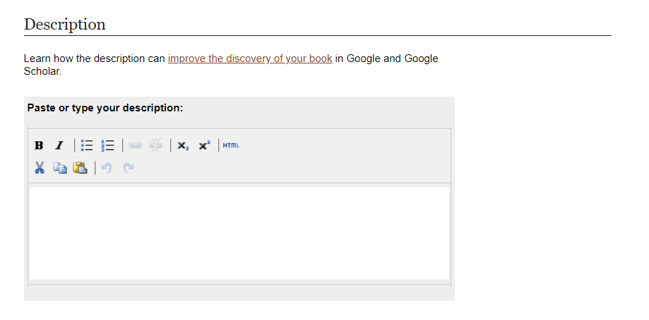
  - In “Submission Date,” you only need to supply the Year. Please use the current year:
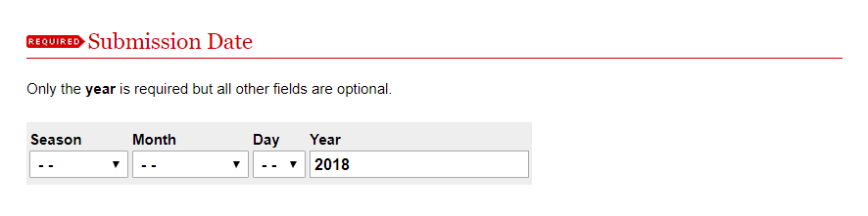

  - Skip the “Comments” section.
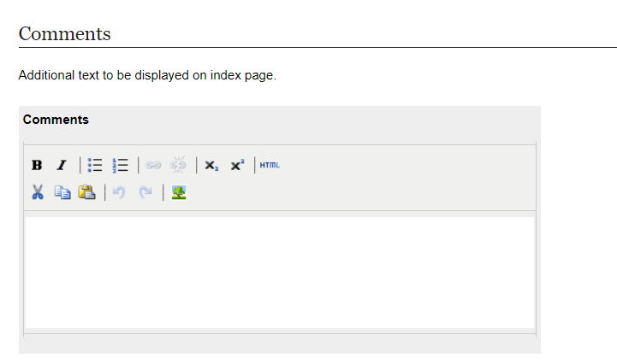
  - In “Upload file,” select “Upload file from your computer” and a “Choose File” button will appear:
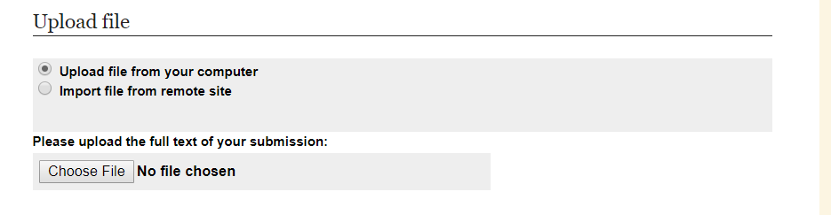
    - Select “Choose File” and a separate window will appear for you to find your file on your computer.
    - Select your assessment report file, and then select open.
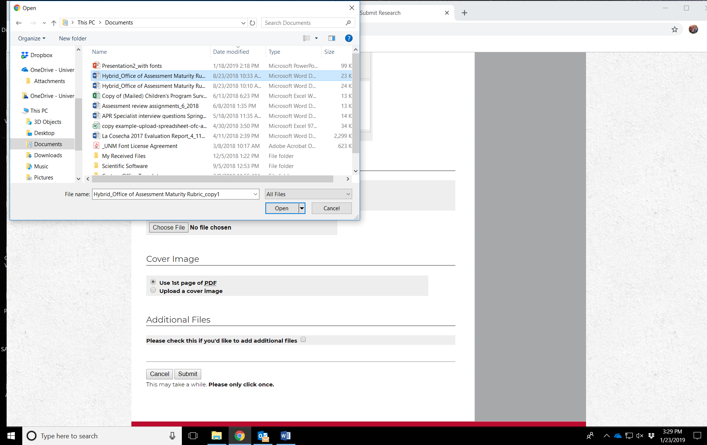
Click Here!
Select your file!

    - Your file will be visible here:
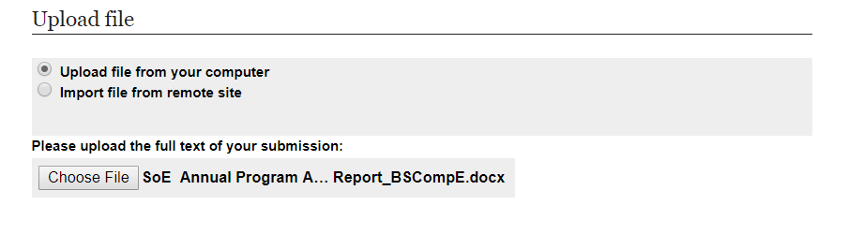
  - “Cover Image” defaults to “Use 1st page of PDF” do not change anything in “Cover Image” unless you have a separate page you would like to use as a cover page.
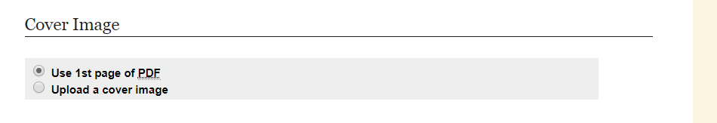
  - In “Additional Files,” check the box if you have more than just a report to submit. You will be prompted to upload the additional files after selecting “Submit.”
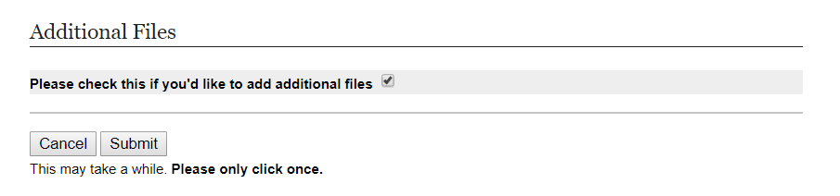

Click Here!
Check here!

  - Now, you will upload your “Supplemental Content,” like a maturity rubric or plan. Click “Choose File” in the gray section of the form:
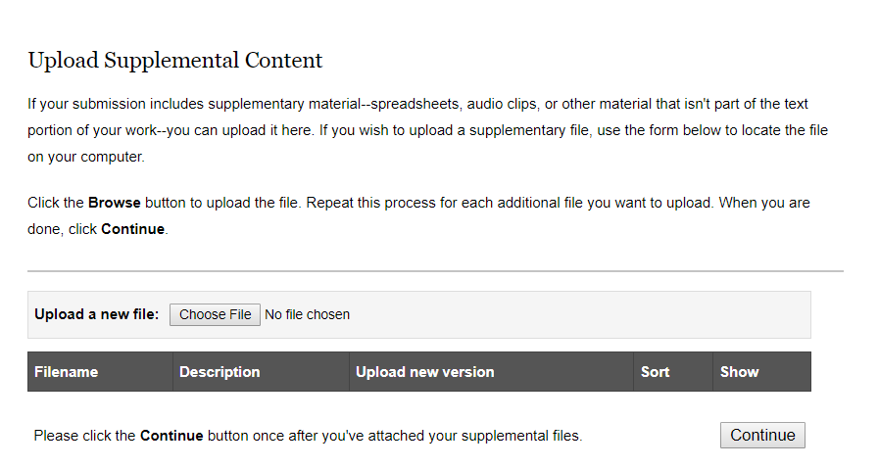
Click Here!
    - You will be prompted again to locate your file and select open:

    - The green box at the top of the page will verify that your supplemental content was uploaded:
    - If you would like, you can add a description of the content in the “Description” box, but it is not required.
    - When you are done, select “Continue.”
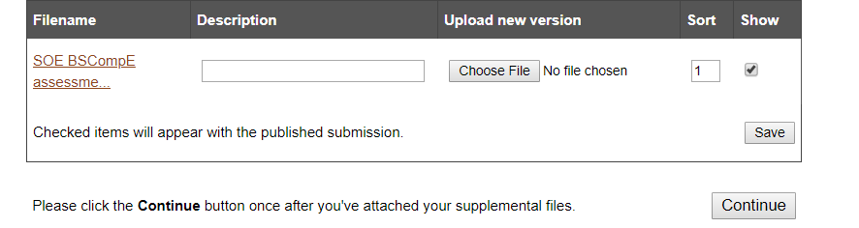
Click Here!
    - Another green box will appear to let you know your submission was uploaded.
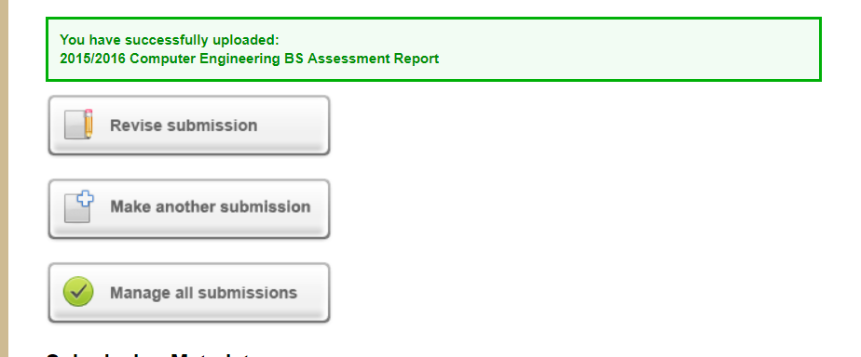
- Once you complete the submission form, the Assessment office will receive an email to review the submission and publish it to the repository. You will also receive an email confirmation once your submission is published or if we need anything additional from you at that point.

